**57. Introduction**

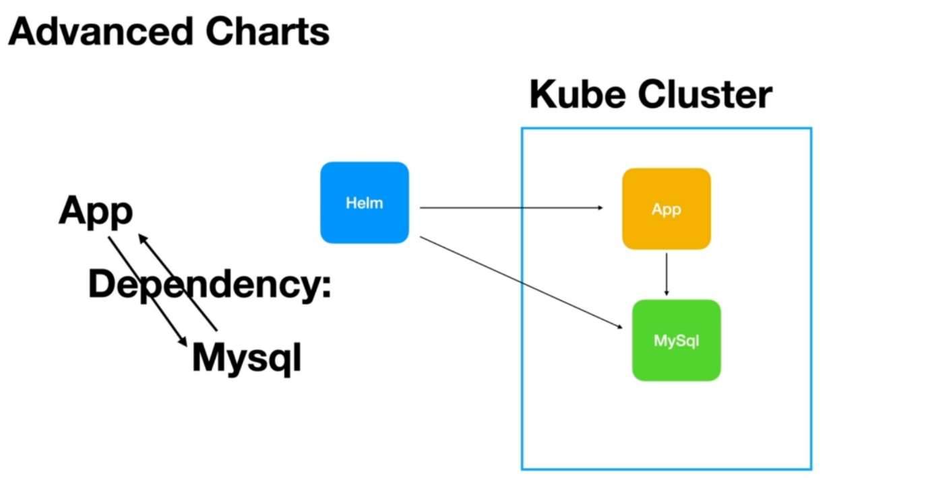

--- you will learn some advanced chart topics starting with chart dependencies.

--- Let us say we are releasing a web application to the Kubernetes cluster or a restful API application to kube cluster, where this application depends on MySQL for it to work, it uses the MySQL database instead of We manually first installing the MySQL server, using the MySQL chart, and then deploying our application or releasing our application.

--- We can define the Mysql chart as a dependency inside our application chart and when we package our application. The MySQL chart will also be included in our applications chart and when we use the helm to deploy this packaged chart, Helm will automatically release the MySQL as well as our application. Application will start using the Mysql, which is running on the kube cluster.

--- You will also learn how to exchange values from the main chart to the dependency chart and from the dependency chart to the main chart.

--- **note** - In this section, you will also learn what Helm hooks are and will create your own hook and you will learn how to configure and use a hook. You will then learn how to test your charts.

Tests are under the test folder.